**CDAC Mumbai PG-DAC AUGUST 24**

**Assignment No- 2**

1)Write a program that checks if a given year is a leap year or not using both if-else and switch-case.

Using if loop:

**package** leap;

**import** java.util.Scanner;

**public** **class** leap {

**public** **static** **void** main(String args[])

{

Scanner sc=**new** Scanner(System.***in***);

System.***out***.println("Enter the year");

**int** a = sc.nextInt();

**if**(a%4==0)

{

System.***out***.println(a+" is leap year");

**if**(a%100==0)

{

**if**(a%400==0)

{

System.***out***.println(a+" is leap year");

}

**else**

System.***out***.println(a+"is not a leap year");

}

}

**else**

{

System.***out***.println(a+" is not a leap year");

}

}

}

Output:

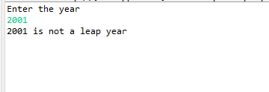

Using Switch case:

**package** leap1;

**import** java.util.Scanner;

**public** **class** leap1 {

**public** **static** **void** main(String args[])

{

Scanner sc=**new** Scanner(System.***in***);

System.***out***.println("Enter the Year");

**int** b=sc.nextInt();

**int** r= b%4==0 && b%100!=0 || b%400==0 ? 1 : 0;

**switch** (r)

{

**case** 1:

System.***out***.println("Year is leap year");

**break**;

**case** 0:

System.***out***.println("Year is not a leap year");

**break**;

**default**:

System.***out***.println("Year is not a leap year");

}

}

}

Output:

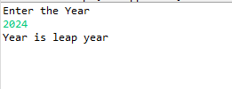

2)Implement a program that calculates the Body Mass Index (BMI) based on height and weight input using if-else to classify the BMI int categories (underweight, normal weight, overweight,etc).

**package** BMI;

**import** java.util.Scanner;

**public** **class** BMI {

**public** **static** **void** main(String args[]) {

Scanner sc=**new** Scanner(System.***in***);

System.***out***.print("Enter the Height in meters");

**double** h=sc.nextDouble();

System.***out***.print("Enter the Weight in KG");

**double** w=sc.nextDouble();

**double** bmi=w/(h*h);

**if**(bmi<=18.5)

{

System.***out***.print("Underweight");

}

**else** **if** (bmi <= 25.9)

{

System.***out***.print("Normal weight");

}

**else** **if**(bmi < 30)

{

System.***out***.print("Over weight");

}

**else**

{

System.***out***.print("Obesed");

}

}

}

Output:

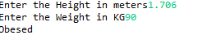

3)Write a program that checks if a person is eligible to vote based on their age.

**package** Vote;

**import** java.util.Scanner;

**public** **class** vote {

**public** **static** **void** main(String args[])

{

Scanner sc=**new** Scanner(System.***in***);

System.***out***.println("Enter the Age");

**int** age=sc.nextInt();

sc.close();

**if**(age<=18)

{

System.***out***.println("Age is Minor not elligible for voting");

}

**else**

{

System.***out***.println("Elligible for voting");

}

}

}

Output:

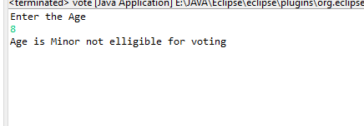

4)Write a program that takes a month (1-12) and prints the corresponding season (Winter, Spring, Summer, Autumn) using a switch case

**package** Season;

**import** java.util.Scanner;

**public** **class** Season {

**public** **static** **void** main(String[] args) {

Scanner sc=**new** Scanner(System.***in***);

System.***out***.println("Enter the Month:");

**int** m=sc.nextInt();

**switch**(m)

{

**case** 1:

**case** 2:

**case** 12:

System.***out***.println("Season is Winter");

**break**;

**case** 3:

**case** 4:

**case** 5:

System.***out***.println("Season is Spring");

**break**;

**case** 6:

**case** 7:

**case** 8:

System.***out***.println("Season is Summer");

**break**;

**case** 9:

**case** 10:

**case** 11:

System.***out***.println("Season is Autumn");

**break**;

**default**:

System.***out***.println("Invalid month");

**break**;

}

}

}

Output:

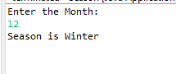

5)Write a program that allows the user to select a shape (Circle, Square, Rectangle, Triangle) and then calculates the area based on user-provided dimensions using a switch case.

**package** area;

**import** java.util.Scanner;

**public** **class** area {

**public** **static** **void** main(String[] args) {

Scanner sc=**new** Scanner(System.***in***);

System.***out***.println("Select the number of your choice");

System.***out***.println("1.Circle");

System.***out***.println("2.Square");

System.***out***.println("3.Rectangle");

System.***out***.println("4.Triangle");

System.***out***.println("Enter the choice :");

**int** a=sc.nextInt();

**switch**(a)

{

**case** 1:

System.***out***.println("Enter the radius of circle :");

**float** b=sc.nextInt();

**float** r=(**float**)3.14*b*b;

System.***out***.println("Area of Circle is :"+r);

**break**;

**case** 2:

System.***out***.println("Enter the side of square :");

**int** c=sc.nextInt();

**int** s=c*c;

System.***out***.println("Area of Square is :"+s);

**break**;

**case** 3:

System.***out***.println("Enter the Lenght and width of Rectangle :");

**int** l=sc.nextInt();

**int** w=sc.nextInt();

**int** d= l*w;

System.***out***.println("Area of Rectangle is :"+d);

**break**;

**case** 4:

System.***out***.println("Enter the Lenght and width of Rectangle :");

**int** g=sc.nextInt();

**int** h=sc.nextInt();

**float** e=(**float**) (1/2*(g*h));

System.***out***.println("Area of Rectangle is :"+e);

**break**;

**default**:

System.***out***.println("Choice is invalid");

**break**;

}

}

}

Output:

